# Chapter 6 – Implementation

**6.1 Login Page**

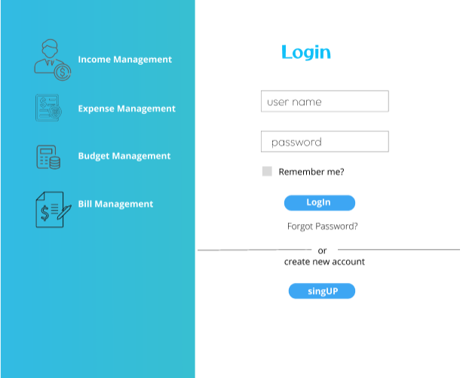

**6.2 Administrator’s Dashboard**

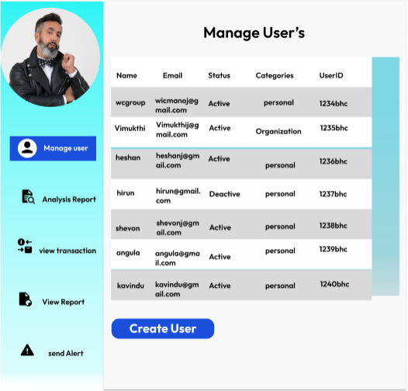

**6.3 User’s Dashboard**

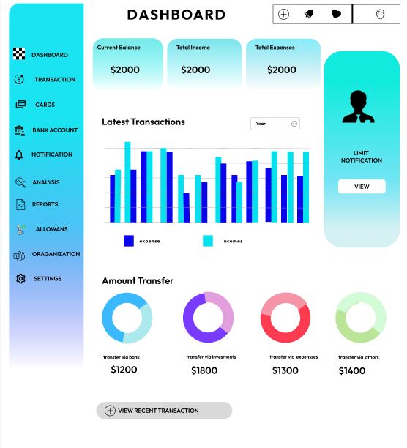

**6.4 Transaction**

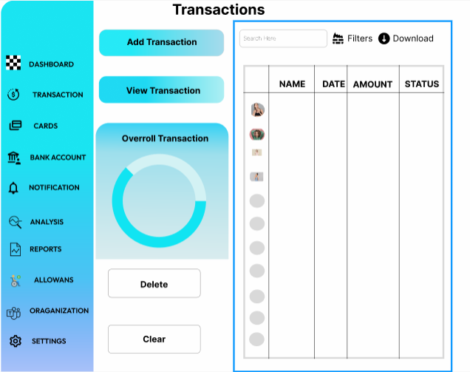

**6.5View Transaction**

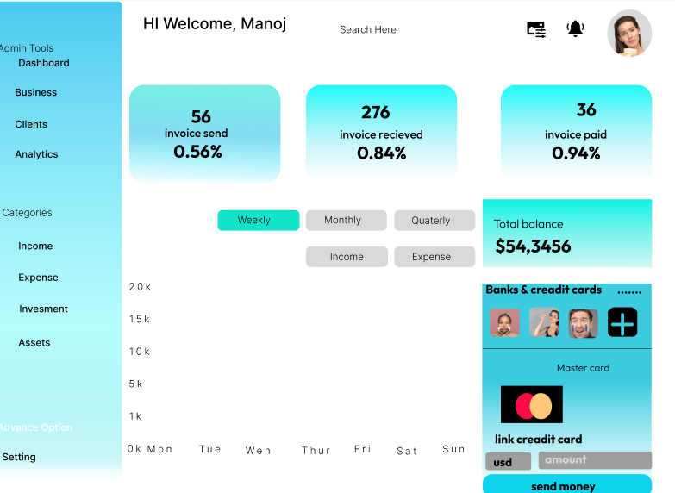

**6.6 Add Transaction**

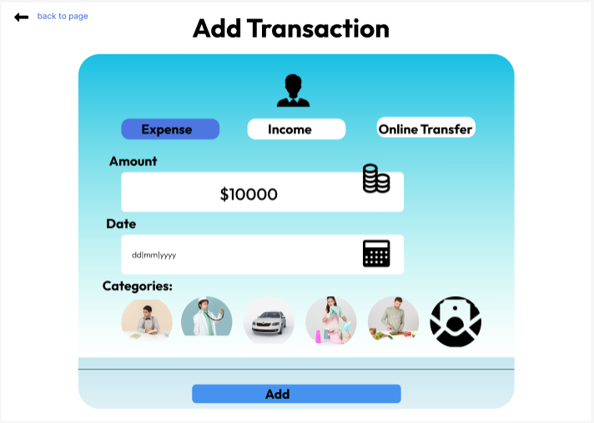

**6.7 Create Saving**

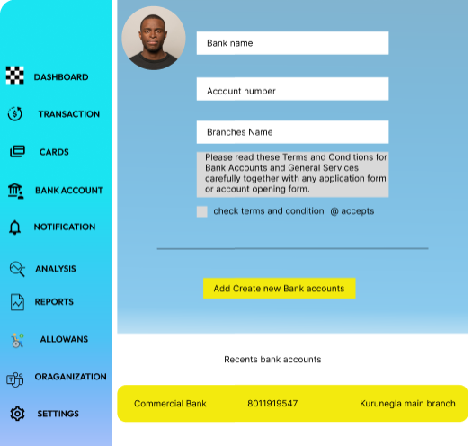

**6.8 Analysis**

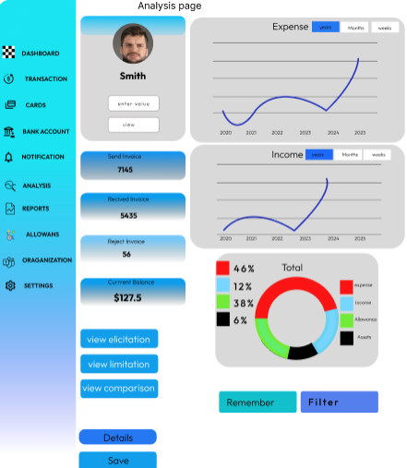

**6.8.1 Create Budget**

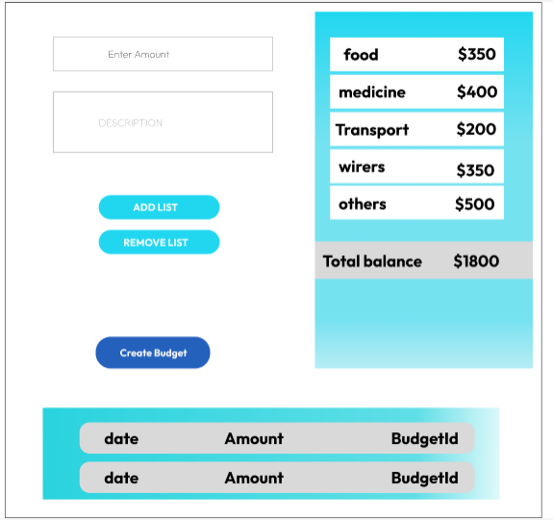

**6.8.2 Create Reminder**

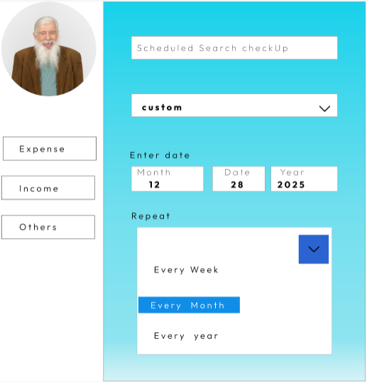

**6.9 Send Alert**

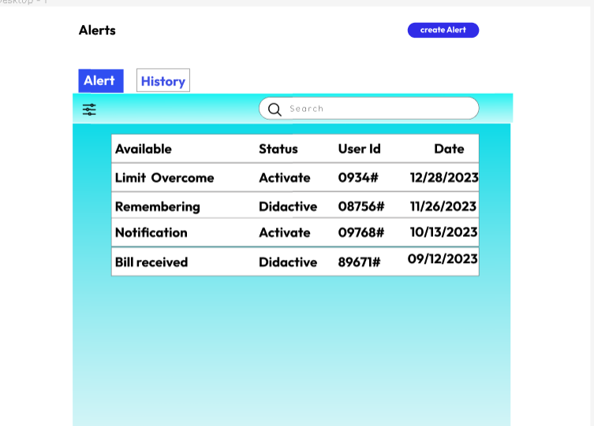

**6.10 Add card**

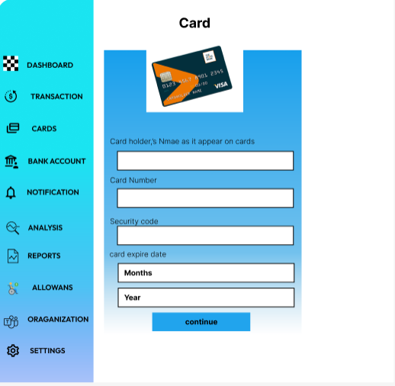

**6.11 View Report**

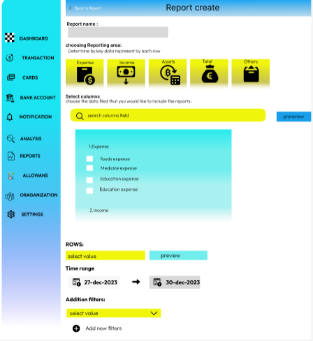

**6.12 Setting**

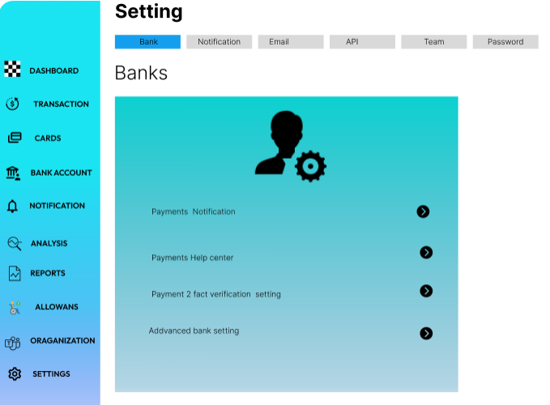

**6.13 Create Before Account Overview**

